LED 19.5'' DELL E2016HV (B)
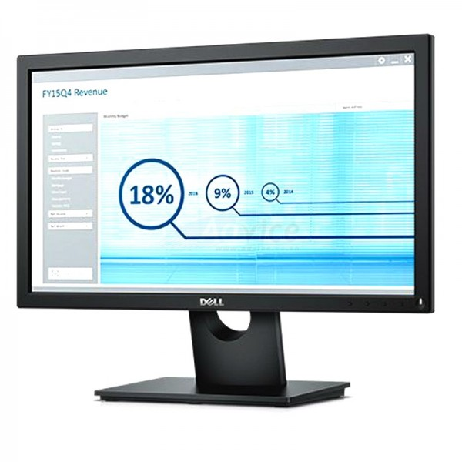
Brand : DELL
Model : E2016HV
Pixel Pitch : 0.248 x 0.248 mm
Response Time : 5 ms typical (Black to White)
Max. Resolution : 1600 x 900 at 60 Hz
Contrast Ratio : 1000:1 (typical)
Brightness : 250 cd/m2 (typical)
Display : 19.5 inches
Viewing Angle : 160° vertical / 170° horizontal
Color System : 16.7 million colors
Audio Speaker : No
VGA Port : 1 Port
Aspect Ratio : Widescreen (16:9)
Warranty : 3Y

